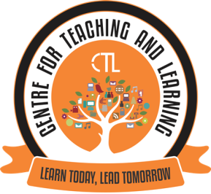
JUNE-2020 (Monthly Report-CTL)
The Centre for Teaching Learning (CTL) powered by IQACconductedExpert FDP Webinar Series on Effective Online Teaching, Learning and Evaluation on 23rd and 24th June, 2020 for the faculty of our College. Dr.SameenaFalleiro, Co-ordinator of CTL Chowgule College was the Convenor of the FDP. She highlighted the Role of CTL in these COVID times and shared with the participants that the Expert Webinar Series is a continuous FDP wherein the CTL provides a platform and invites eminent Experts in the area of ICT and Education to share their expertise with the faculty. The CTL also plans to organise regular in-house training and interactive sessions for the college faculty.
Dr. Vini Sebastian, Associate Professor, St. Xavier’s Institute of Education, Mumbai was the Resource person for this FDP. The topics covered were E-content and OER, Online Transaction – The New Normal, Blended Learning – Boosting Student Engagement, Teaching Methodologies and E-assessment.Around 60 Faculty from our college participated in this event.
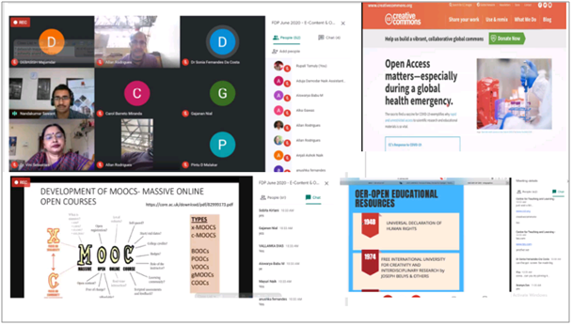
Screenshots of the FDP webinar in progress via Google Meet
1. Mr. Andrew Barreto, Assistant Professor and Co-Coordinator of CTL, conducted a session on E-portfolio on 25th June, 2020 for the faculty of our college. Around 10 Faculty from our college participated in this event.
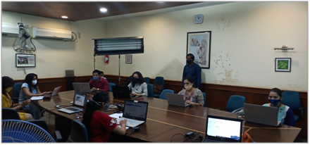

AUGUST-2020 ( Monthly Report-CTL)
The Centre for Teaching Learning (CTL), powered by IQAC in the month of August, 2020 conducted Expert FDP webinar series II on “Effective Online teaching Learning Evaluation” on 10th August, 2020 for the college faculty. Ms. Priya Lotlikar, Research Scholar, Department of Educational Technology, IIT Bombay was the resource person for this FDP. This FDP focussed on Transitioning to online Instruction (from face to face classroom): towards creating Learner- Centric Environment. FDP was attended by around 50 college faculty. Apart from the FDP series CTL Team worked in designing a Course schedule template, setting tasks and time lines and also suggested guidelines for execution and review of the tasks in view of online teaching learning.

CTL also organised a training session on "Chunking” conducted by Dr. Sameena Falleiro, Associate Professor in the Department of Computer Science and the Coordinator CTL on 5th and 6th August, 2020 from 11:00 am to 12:00 pm ( 1 hour duration) in the Flipped Learning classroom. The CTL is also involved in conducting one on one hands-on training sessions for the college faculty on Multimedia Editing S/W led by the Mr. Andrew Barreto, Assistant Professor, Co-Coordinator CTL.

The Launch of "EVidya", "Harnessing Knowledge, Igniting Minds" an Online Teaching Learning Initiative of Parvatibai Chowgule College of Arts and Science, Autonomous, Margao Goa for the Academic Year 2020-2021 was held on 31st August, 2020 at 10.30am via Google Meet for all the college teaching staff. With the eLaunch of eVidya, Chowgule College aims to deliver quality eContent to the students.
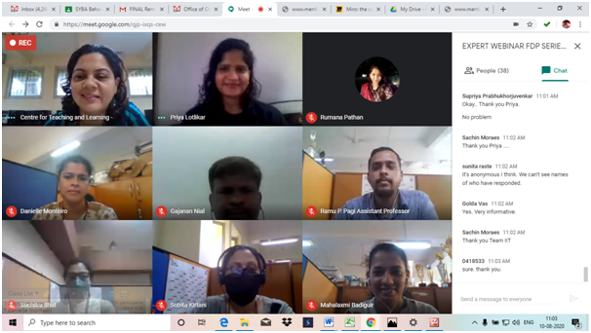
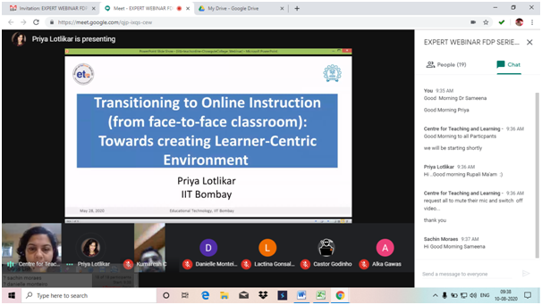

Expert FDP Webinar Series II (August10th, 2020)

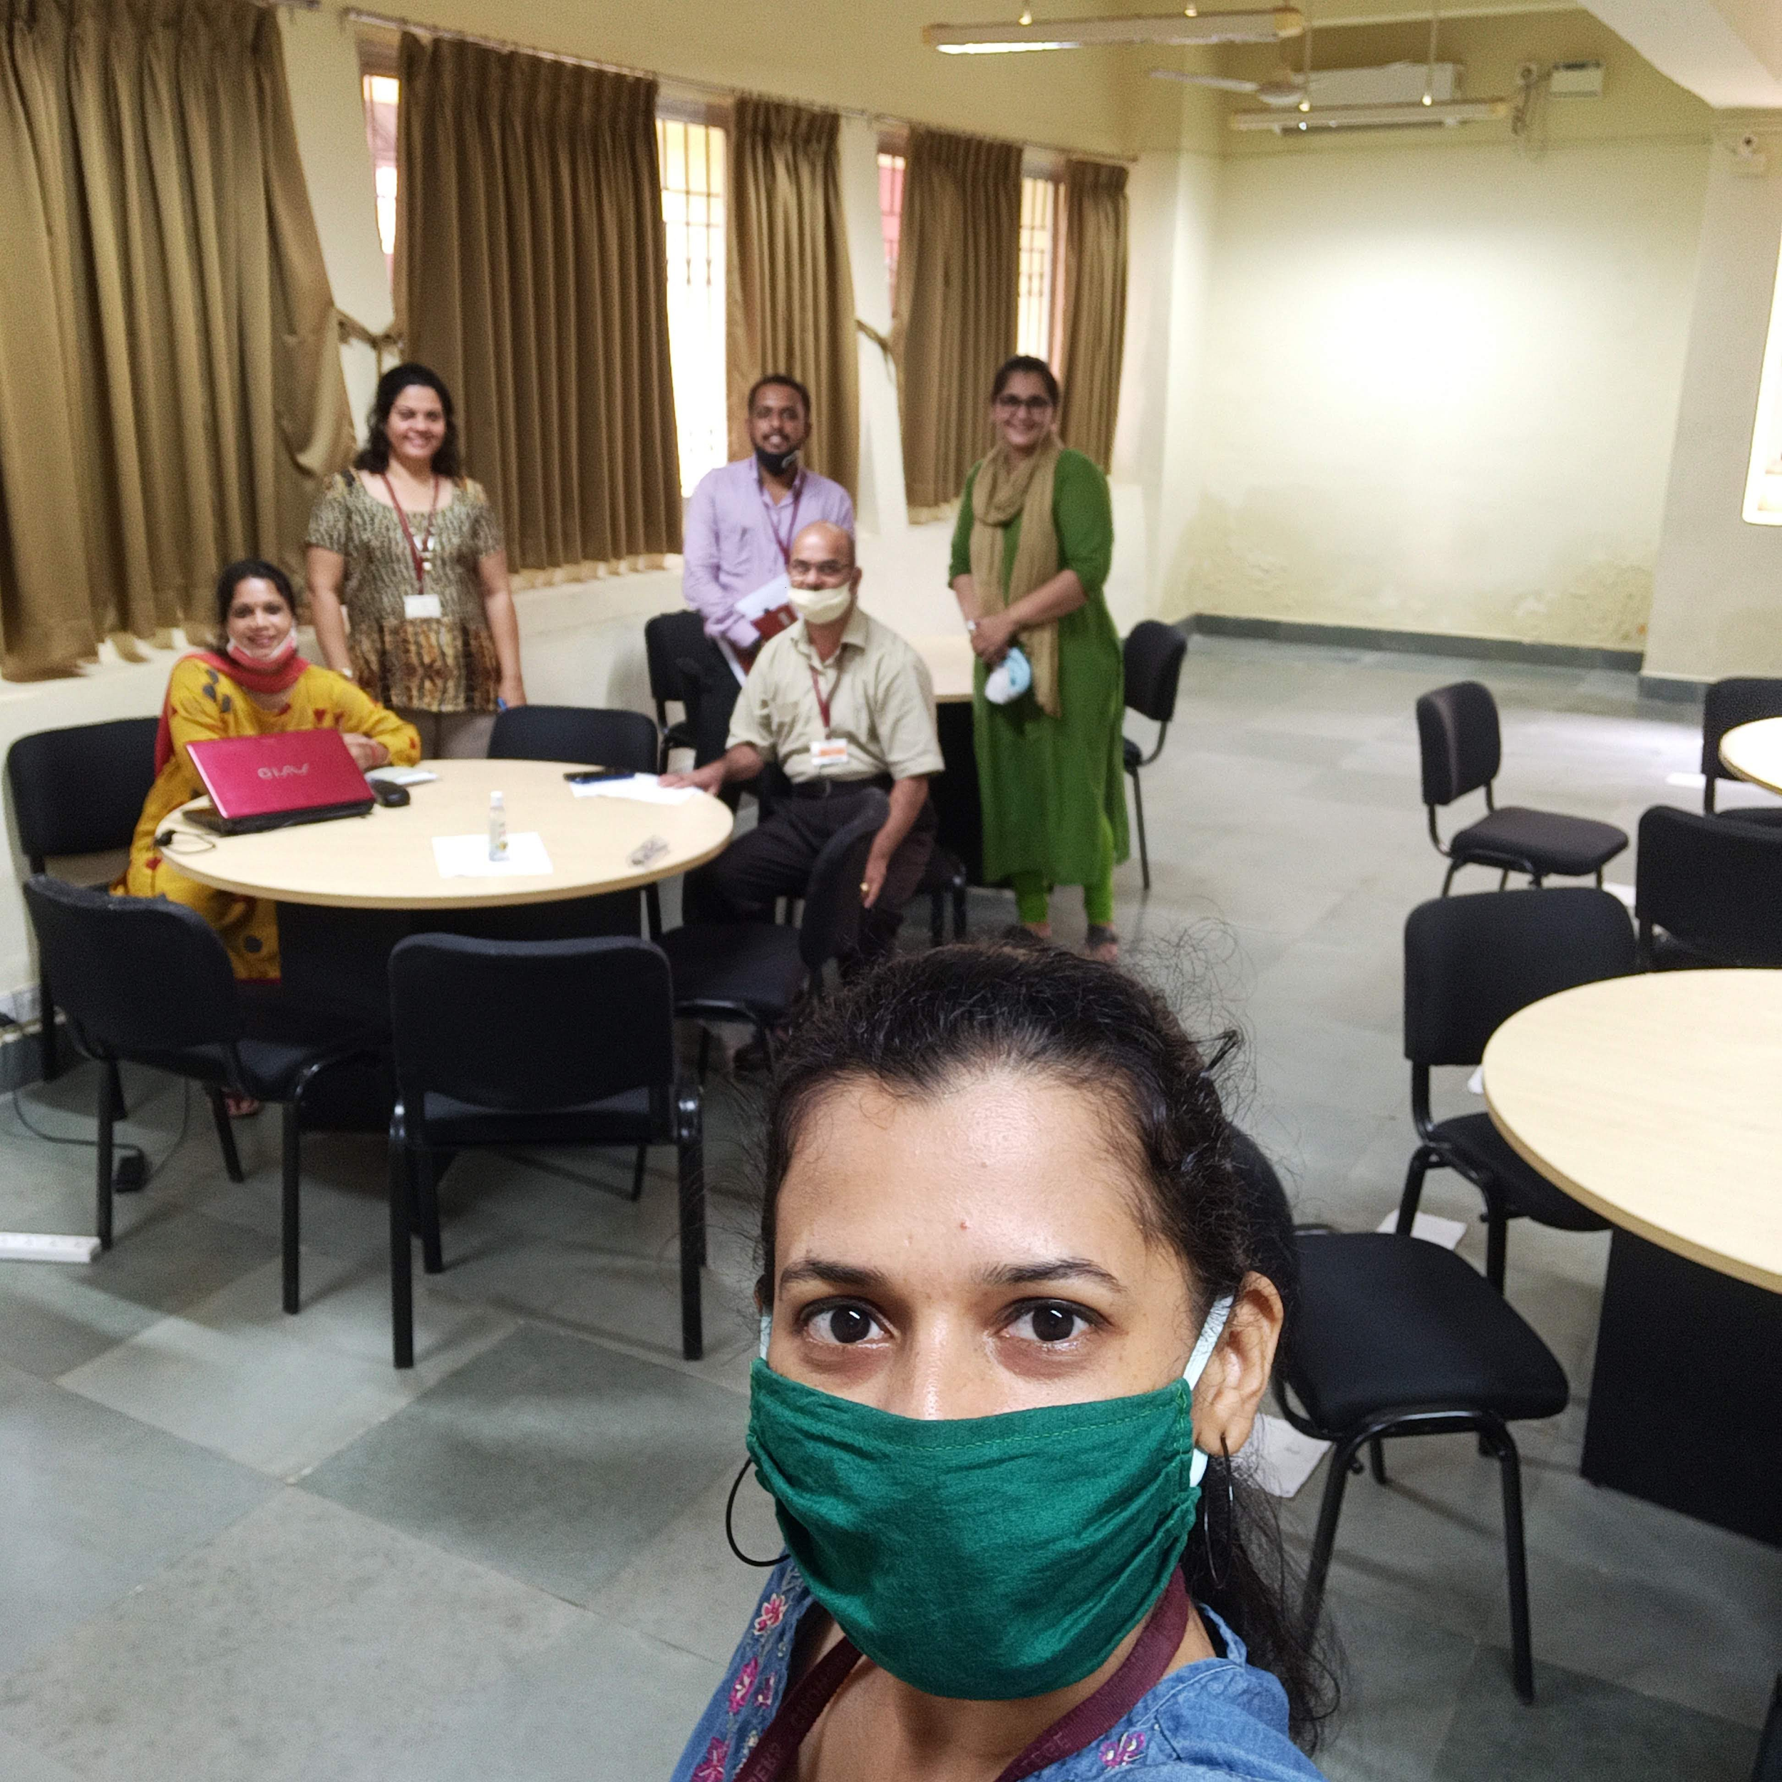
Training session on “Chunking” conducted by Dr. Sameena Falleiro, Associate Professor, Coordinator CTL

OCTOBER-2020 (Monthly Report-CTL)
The Centre for Teaching Learning (CTL) in association with the IQAC of the College, organised the Expert FDP webinar series III on the topic “Preparing for Remote Teaching and Learning; Sharing Experiences” on 5th October, 2020 for the college faculty.
Dr. Aparna Katre, Associate Professor of Cultural Entrepreneurship, Department of World Languages and Cultures, College of Liberal Arts, University of Minnesota - Duluth, USA was the resource person for this FDP.
This FDP focused on Sharing of Experiences with respect to Remote Teaching Learning Evaluation(TLE) from Foreign Universities; Exposure to the Faculty to various online TLE Trends. The Resource person focused on the three main topics i.e. thinking about Curriculum, Student Engagement, Student Feedback-Formative and Summative.
The FDP webinar Series III was attended by around 23 college faculty.

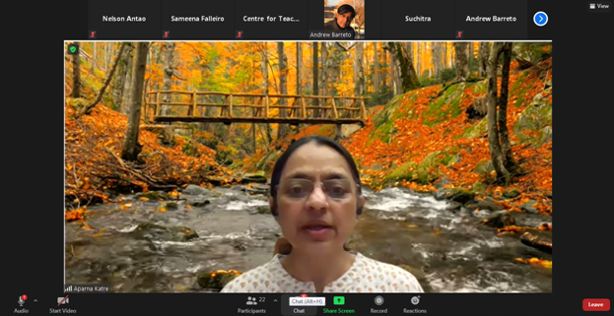
Dr. Aparna Katre, Resource person delivering the session on Preparing for Remote Teaching Learning

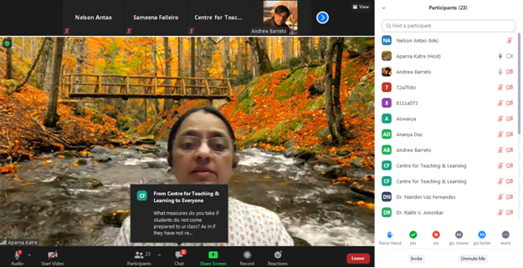

Dr. Aparna Katre, while delivering the session also addressed to all the questions raised by the faculty’s

NOVEMBER-2020 (Monthly Report-CTL)
The Centre for Teaching Learning organised a workshop on ’Training programme on G suite for Non teaching staff’. In house training session was conducted on 20/11/2020 from 3.00pm to 4.30 pm. with an objective to assist the staff in their daily administrative work. The focus of this workshop was to give elementary exposure on functionalities of google drive such as google sheet, google doc and google forms. The staff was given hands- on training.
This training will help the participants in efficient data collection and document sharing.
The resource person for the training session was Ms Rupali Tamuly, Department of Economics of this college.
This was attended by 13 Non teaching staff members.

DECEMBER-2020 (Monthly Report-CTL)
The Centre for Teaching Learning conducted a workshop cum Training programme on ‘G suite’ for Non-teaching staff in two batches on 20th November,2020 and 4th December,2020 with the objective to assist the staff in their daily administrative work.The focus of this workshop was to give elementary exposure on functionalities of Google drive such as Google sheet, Google doc and Google forms. The staff was given hands- on training. This training will help the participants in efficient data collection and document sharing.
The Centre for Teaching Learning (CTL) in collaboration with the International Exchange Programmes of the College, organised the Expert FDP webinar series IV on the topic “Teaching Writing across Disciplines in the Age of Online Education” on 9th December, 2020 for the college teaching faculty.
Prof. Saori Sadoshima, Faculty of International Research and Education, Waseda University, Tokyo was the speaker for this FDP.
This FDP focussed on; various types of online teaching including blended learning, break off and hybrid type of learning which they have been experimenting at Waseda University, Tokyo and also simultaneously highlighted the challenges faced in their implementation. The speaker also gave an insight into Waseda’s academic writing course where she also explained the concept of having Teacher Assistants.The FDP webinar Series IV was attended by around 13 college faculty.

Training programme on ‘G suite’

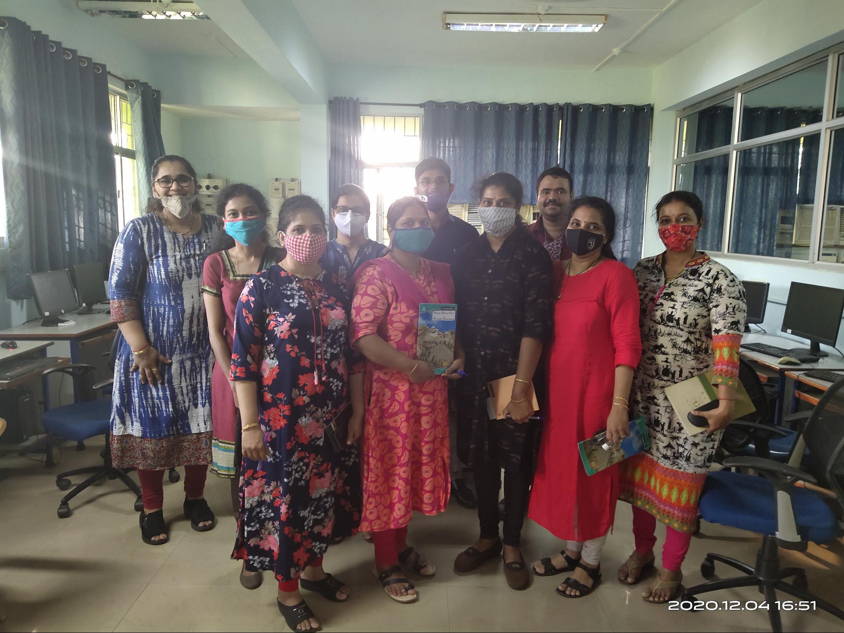
Mrs Rupali Tamuly, CTL member, conducted the training programme on ‘G-suite’ for Non-teaching staff.

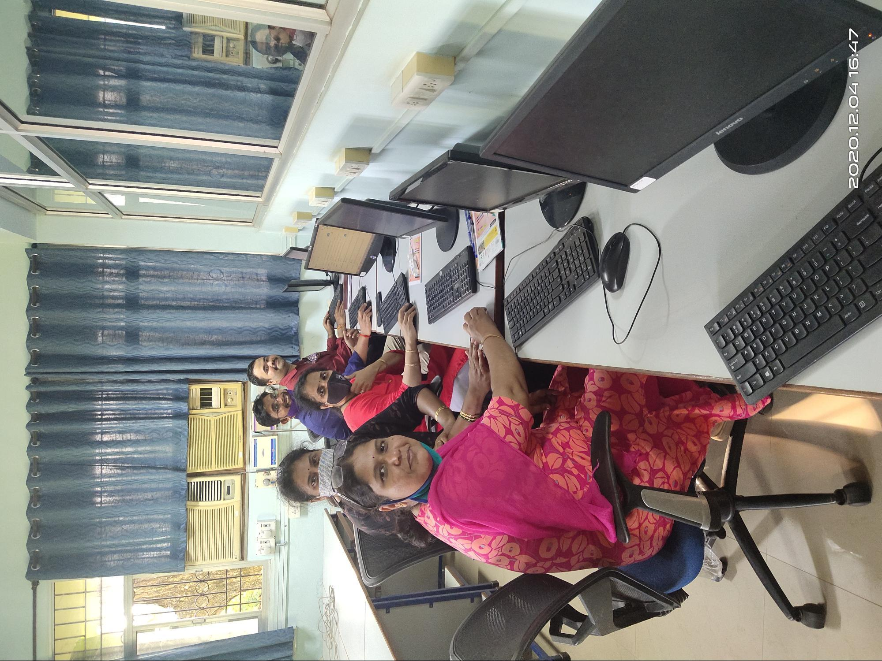
The Non Teaching Staff of the college attending the training session.
Expert FDP webinar series IV: “Teaching Writing across Disciplines in the Age of Online Education”

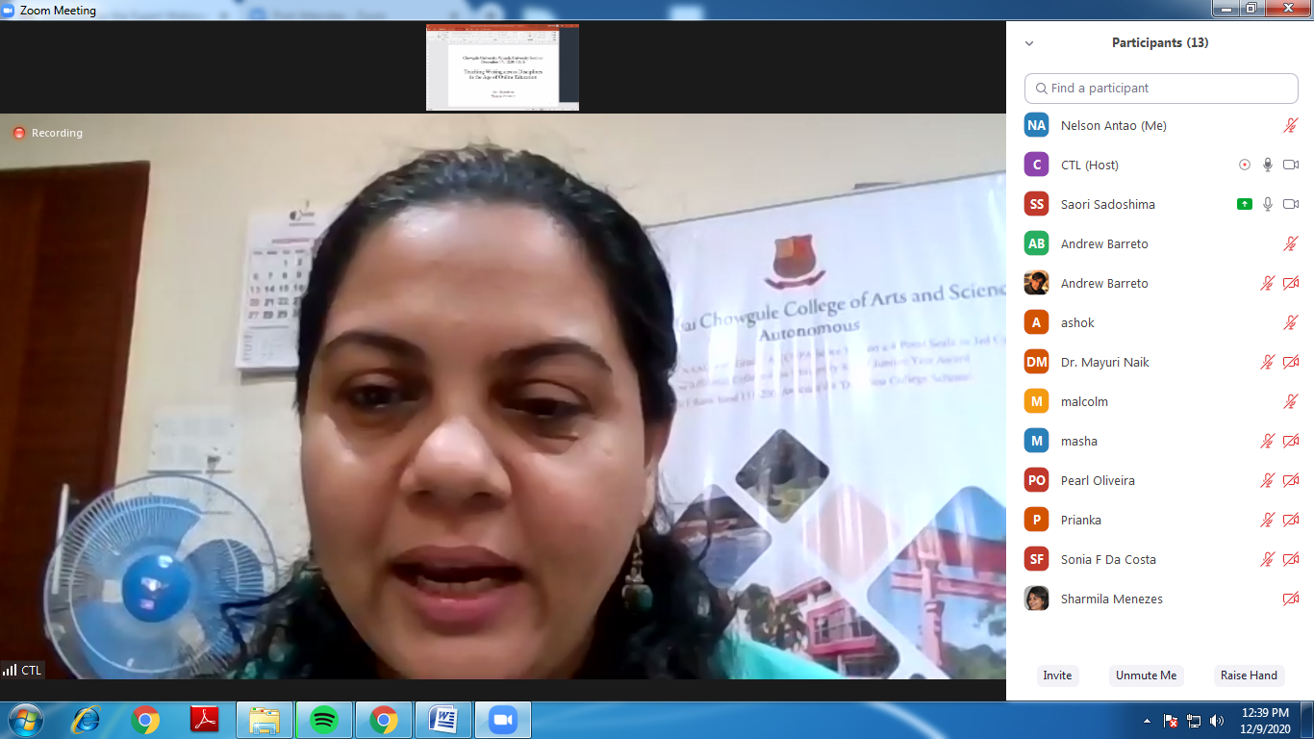
Dr Sameena Fernandes e Falleiro, CTL Director, Introduced the Speaker Prof. Saori Sadoshima and welcomed all the participants for the webinar

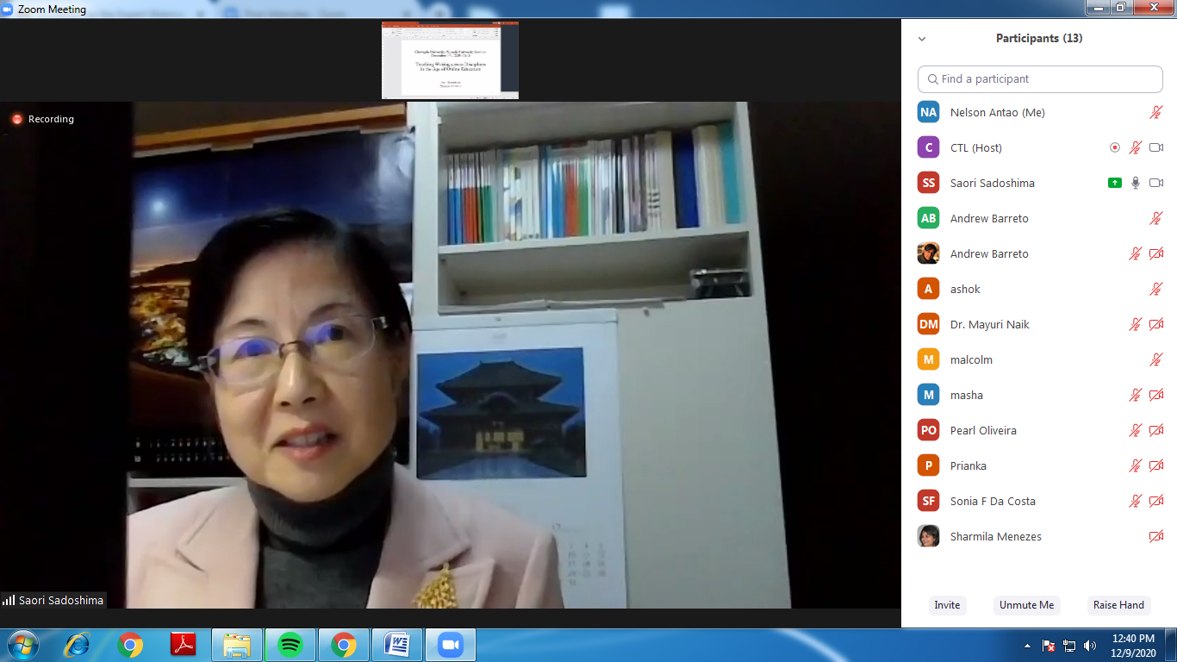
Prof. Saori Sadoshima delivering the session on ‘Teaching Writing Across disciplines in the Age of Online Education’
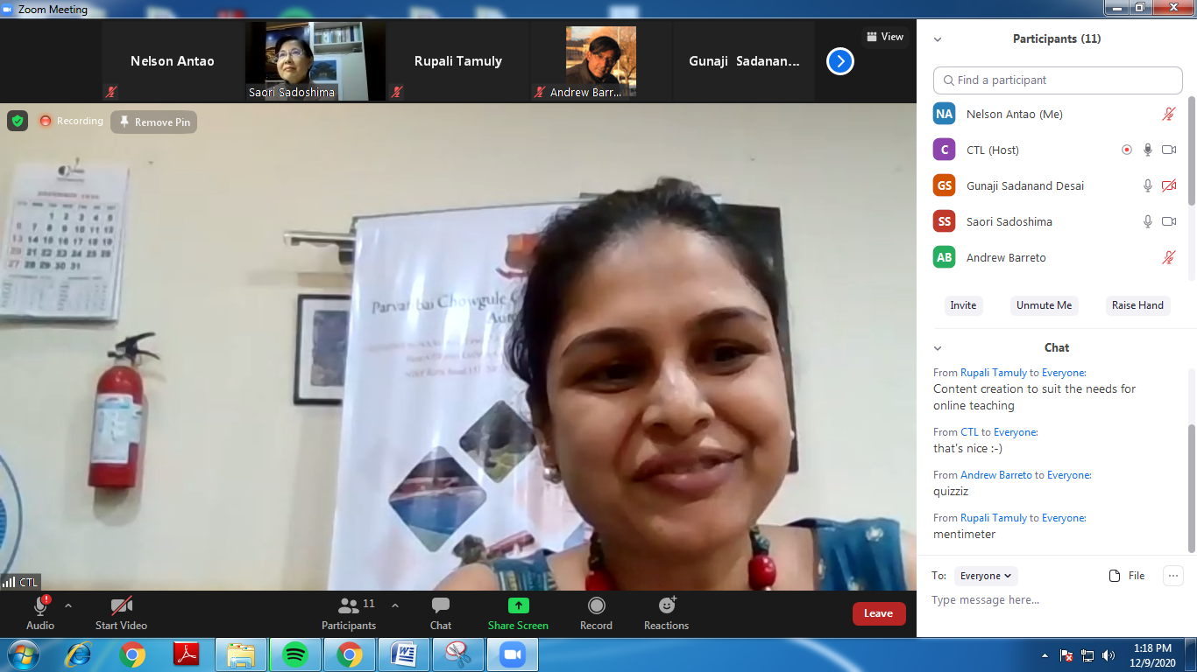

Mrs Sharmila Menezes, Coordinator International Exchange Programmes delivered the vote of thanks to Prof. Saori Sadoshima, Speaker for the webinar for delivering such an enriching session.

JANUARY-2021 (Monthly Report-CTL)
The Centre for Teaching Learning (CTL) organised the Expert FDP webinar series V on the topic “Fundamentals of Online Learning Engagement” on 25th January, 2021 for the college teaching faculty.
Mrs. Rosemaliza Mohd. Kamalludeen (Ph.D), Assistant Professor, Department of Instructional Technology, Kulliyyah of Education, IIUM, Malaysia was the speaker for this FDP.
This FDP focussed on how to engage in online teaching. Various teaching tools were also briefly introduced. She also spoke about how online assessment can be carried out and gave ideas and tips for smooth functioning of online learning. The FDP webinar Series V was attended by around 21 college faculty.

Expert Webinar FDP Series - V Photographs

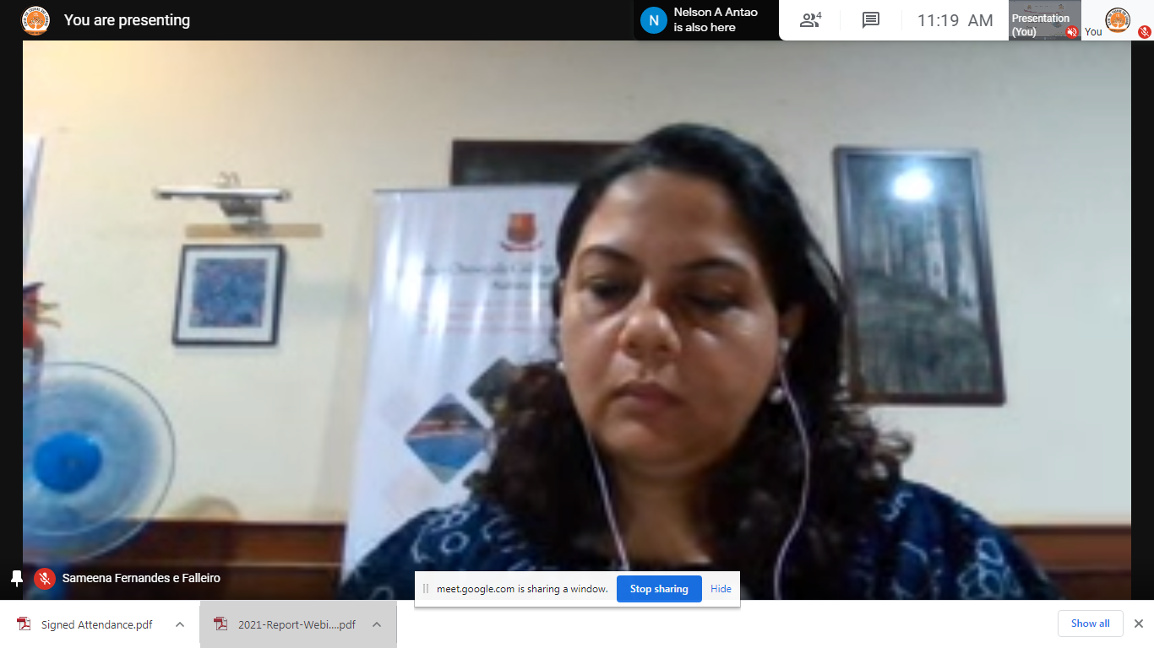
Dr Sameena Falleiro, Coordinator CTL introducing the speaker of the webinar to all the participants

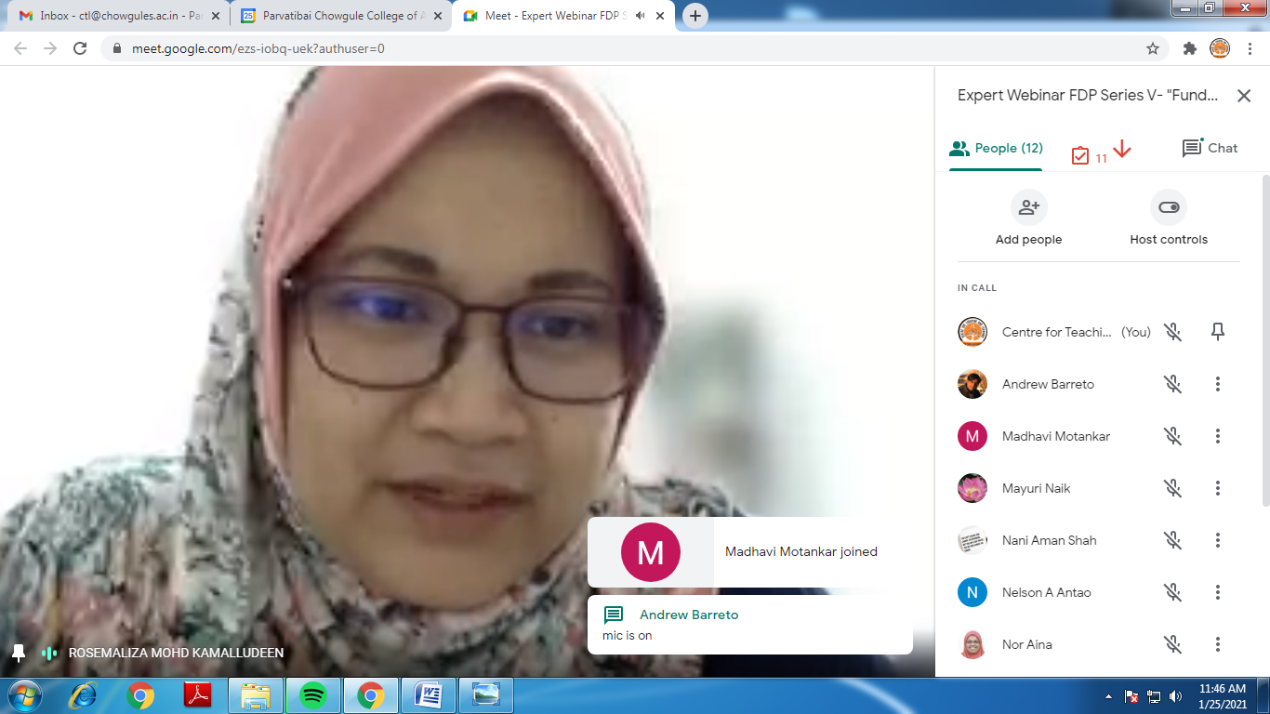
Mrs Rosemaliza Mohd. Kamalludeen (Ph.D) was the speaker for the Expert webinar FDP series – V

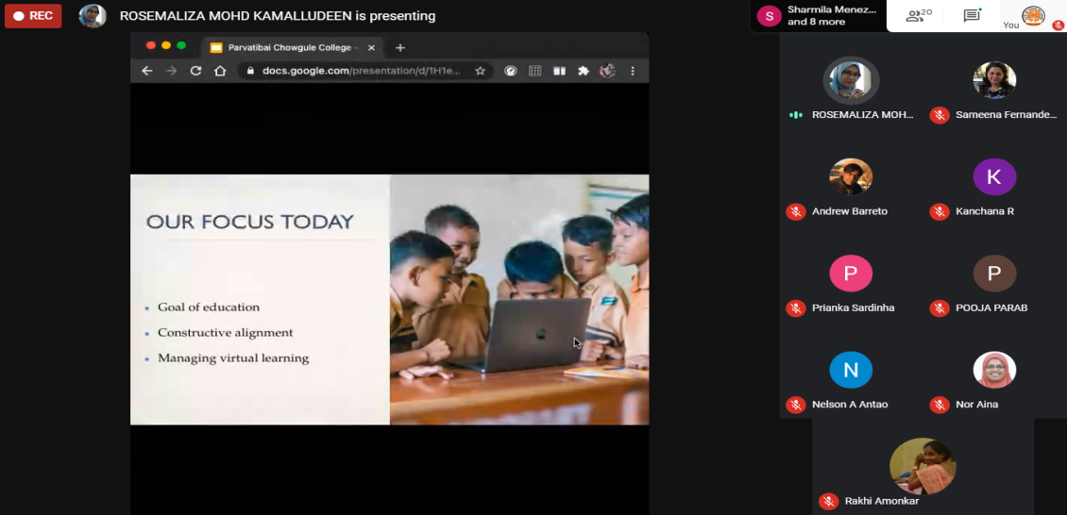

The Speaker delivering the session on the topic “Fundamentals of Online learning engagement”

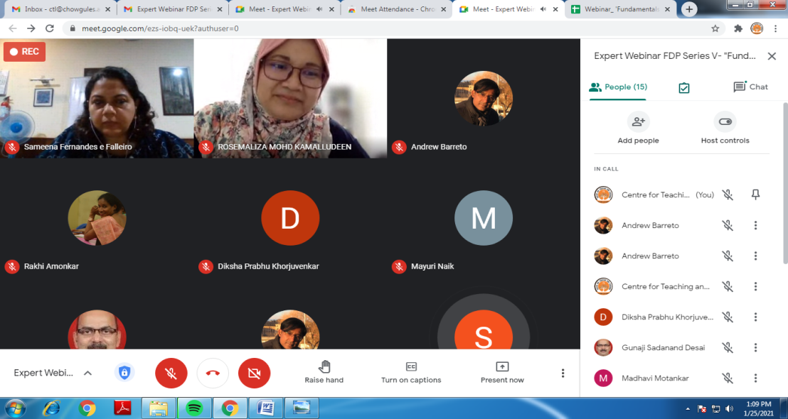
The resource person answering to all the queries of the college faculty

APRIL-2021 (Monthly Report-CTL)
The Centre for Teaching Learning (CTL) organized the following Activities/Programmes in the Month of April 2021.
- An Orientation cum Training programme on using OBE Portal. The main objective of this session was to demonstrate the OBE portal and give hands-on training to College faculty on the same. It was conducted on 17th April, 2021 in the Lower Auditorium and attended by 4 Faculty. Assistant Professors Ms. Dikshita Aroskar and Ms. Ashweta Anand Fondekar from the Department of Computer Science were the resource persons for the same. An LOCF Portal Manual was also prepared so that Faculty can use it as a resource.
- Expert FDP Webinar Series VI on the topic “Perspectives of NEP 2020: Technology in Higher Education” on 29th April, 2021 via GMeet for the college teaching faculty.
Dr.R.C.Sharma, Associate Professor n Instructional Design and Educational Technology was the Resource Person at this FDP.
This FDP focused on certain terminologies/annotations used in the NEP; It also focused on Learning Paths and Competencies so that Faculty can use techniques in teaching, learning and evaluation so that we can create students who are self-directed lifelong learners. The FDP webinar Series V was attended by 28 college Faculty.

FDP VI Photographs
The Resource Person Dr.R.C.Sharma delivering the FDP and Answering Participant Questions
